**Fitness Gym**

**GROUP MEMBERS:**

**Sufyan Ahmed Khan ID 1403275**

**Salman Khan ID 1477211**

**Batch number PR2-202307G**

# *Certificate of Completion*

This is to certify that **Sufyan Ahmed Khan,** and **Salman Khan**

have successfully completed their E-Project.

Submitted to: **Aptech Computer Education**

On

**DEC 17th ,2023**

# *Acknowledgement*

First of all we would like to thank Almighty Allah for giving us strength and ability to complete this project.

And then, we would like to express my special thanks of gratitude to our teacher **Sir Baran** who guided us on the project *Music Website*, which also helped us in doing a lot of new learning and we came to know about so many new things we are really thankful to him.

We are highly thankful to **Sir Baran** for his guidance and constant supervision as well as for providing necessary information regarding the project & also for his support in completing the project.

Lastly, we would also like to thank our parents and friends who helped us a lot in finalizing this project within the limited time frame. We also express our sincere gratitude to E-Project team from Aptech Head Office, for their valuable guidance and support for the completion of this project. We earnestly hope that this project will provide all the necessary information required by the user to fulfill his/her inspiration. However, suggestion and Feedbacks for improvements will be thankfully welcomed & acknowledged*.*

# *Project Synopsis*

This website belongs to Gym Fitness, its an entertaining website, this website displays the number of music, Rock, Jazz, Pop, Rap, Classical

It entertains in the following ways

* Allow audience to listen the rock music
* Allow

# *Functional Requirement*

1. Home
2. About us
3. Membership
4. Pages
5. Our Machine
6. ***With Sub- Pages Of:***

Cycling

Swimming

Spa & Saloon

Training

# *Hardware and Software Requirements*

**Hardware/ Software Requirements**

**Hardware**

* A minimum computer system that will help you access all the tools in the courses is a Pentium 166 or better
* 64 Megabytes of RAM or better

**Software *[Either or Combination as per Course/Sem]***

* Notepad/HTML editor/CoffeeCup
* Angular / Angular JS / React / BootStrap
* Dreamweaver / Figma
* MS IE / Chrome / FireFox / Netscape /MS Edge

**Site Map**

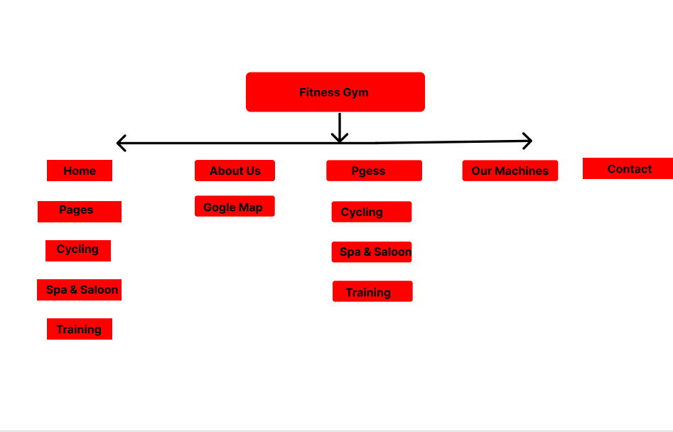

*Task Sheet*

|  |  |  |  |  |
| --- | --- | --- | --- | --- |
| Project Ref. No. | | Project Title | Date of Preparation of Activity Plan | |
| S.No. | Task | **Music Website** | Actual Days | Status |
| 1 | Analysis | 1 | OK |
| 2 | Design | 5 | OK |
| 3 | Development | 2 | OK |
| 4 | Testing | 1 | OK |
| 5 | Documentation | 1 | OK |



